EXPERIMENT – 3

EXP No: 3

Date: ___________

Title
DML Commands – INSERT and SELECT

AIM
To perform INSERT and SELECT operations on the Drone Delivery Management System database.

DESCRIPTION
DML (Data Manipulation Language) commands are used to insert and retrieve records from database tables.

PROCEDURE
- Open MySQL Command Line.
- Select the DroneDelivery database.
- Insert records into Customers, Drones and Deliveries tables.
- Display the inserted records using SELECT statements.

Query 1

USE DroneDelivery;

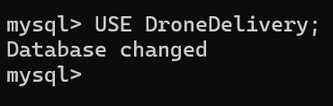

Query 2

INSERT INTO Customers

(CustomerID, CustomerName, Phone, Address, Email)

VALUES

(101,'Rahul','9876543210','Hyderabad','rahul@gmail.com'),

(102,'Anitha','9123456780','Vijayawada','anitha@gmail.com'),

(103,'Kiran','9988776655','Ongole','kiran@gmail.com');

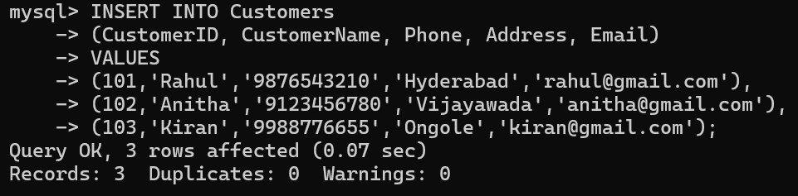

Query 3

INSERT INTO Drones

(DroneID, DroneModel, PayloadCapacity, DroneStatus, BatteryHealth)

VALUES

(201,'DJI Mini',5.50,'Available',95),

(202,'DJI Air',8.00,'Busy',82),

(203,'QuadX Pro',10.00,'Maintenance',60);

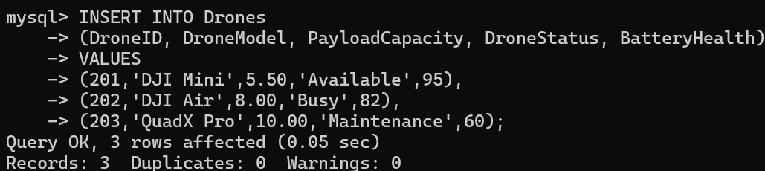

Query 4

INSERT INTO Deliveries

(DeliveryID, CustomerID, DroneID, Destination, DeliveryDate, DeliveryStatus)

VALUES

(301,101,201,'Guntur','2026-08-05','Delivered'),

(302,102,202,'Vijayawada','2026-08-06','Pending'),

(303,103,203,'Ongole','2026-08-07','In Transit');

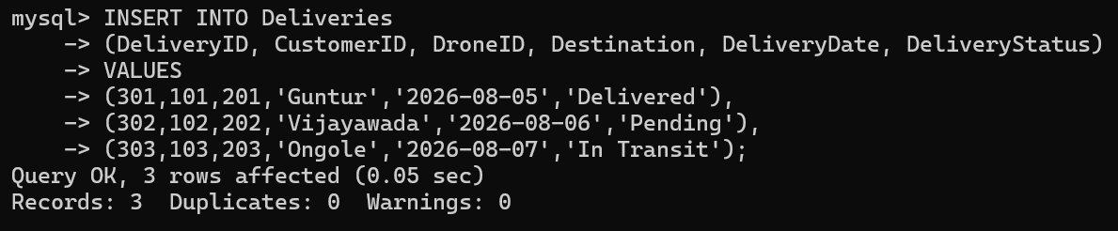

Query 5

SELECT * FROM Customers;

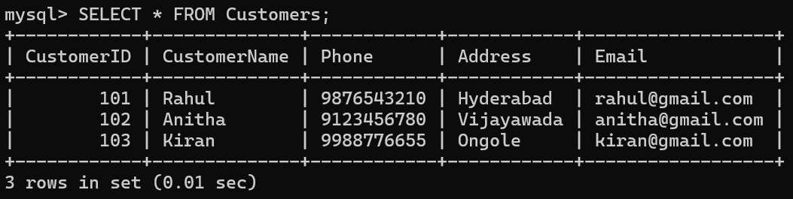

Query 6

SELECT * FROM Drones;

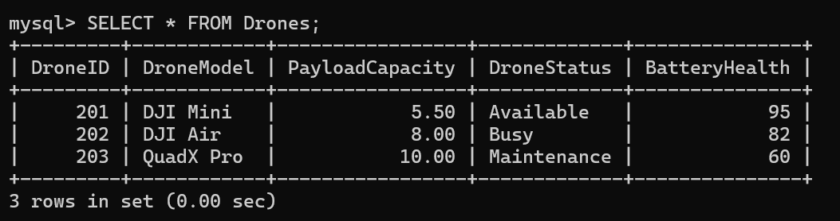

Query 7

SELECT * FROM Deliveries;

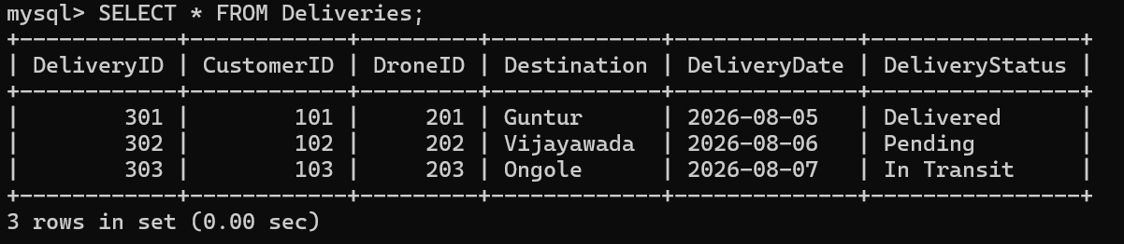

Query 8

SELECT CustomerName, Phone

FROM Customers;

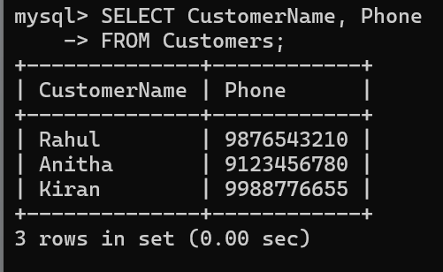

Query 9

SELECT DroneModel, DroneStatus

FROM Drones;

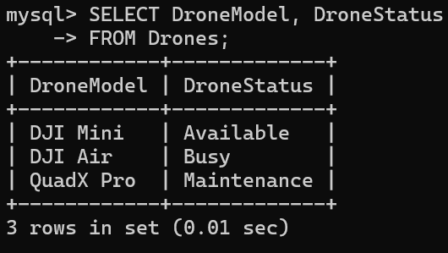

Query 10

SELECT DeliveryID, DeliveryStatus

FROM Deliveries;

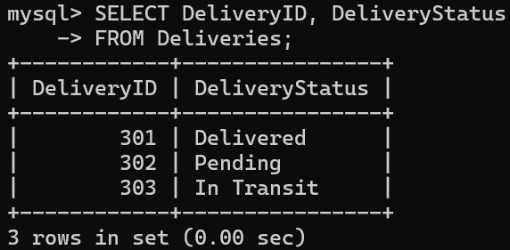

RESULT
Thus, the INSERT and SELECT operations were successfully performed on the Drone Delivery Management System database.

